

**MAIRA EMAAN NASIR**

**BSCS**

**2430-0153**

**PROGAMMING FUNDAMENTAL LAB**

**TASK 2**

**QUESTION: 01**

**SCREENSHOT:**

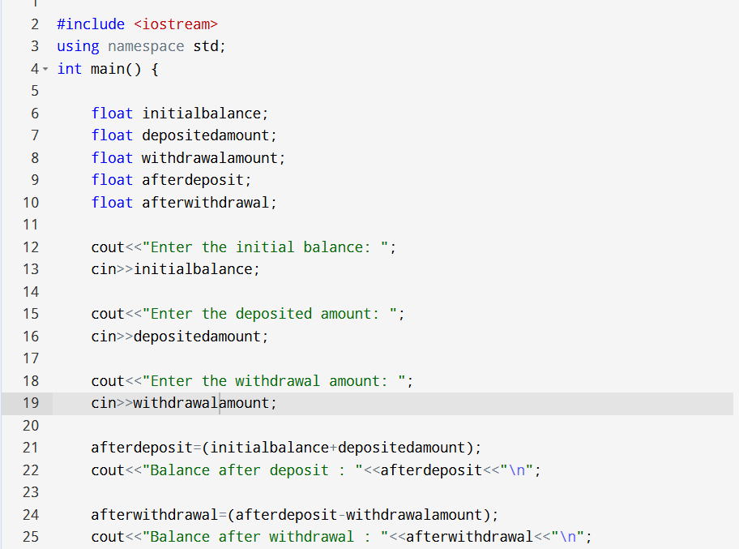

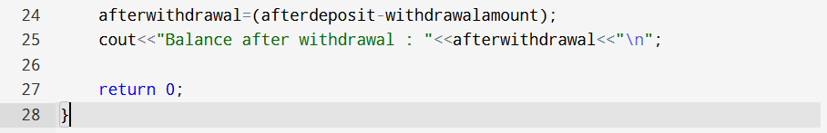

OUTPUT:

